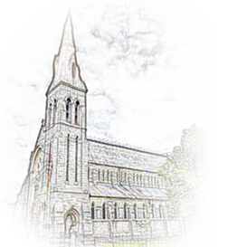
St. Patrick’s Parish Monkstown
Parish Office: Parochial House, Carrickbrennan Road, Monkstown, Co. Dublin
Tel: (01) 538 2542
Email: secretary@monkstownparish.ie
web: www.monkstownparish.ie

Baptism Booking / Registration Form
Information for the Baptismal Register
Strictly Private and Confidential

Date of Birth: Click or tap here to enter date of birth.
Name(s) of Child: Enter Child’s name(s) as per their Birth Certificate
Name of Father: First Name and Surname
Name of Mother: First Name and Maiden Name
Address of Parents: Click or tap here to enter text.
Contact Details: Please enter either mobile number or email or both
Godfather: Name of Godfather
Godmother: Name of Godmother
Date of Baptism Click or tap here to enter text.

Signature:

PRIVACY STATEMENT
- The Information contained in this form will be used to register this Baptism in the parish.
- The copy of the Birth Certificate you submitted will be destroyed once the Baptism is registered.
- The Information in the Parish Register will be retained permanently.

